West Indians in New York
Gigantic Mall

On Wednesday, march 20th, while 3 of us woke up at 4am to do the queue and go to Jimmy Fallon’s show, we woke up and heard that everyone got to go to the show, so we took a quickly bath and run to join them. You know, it’s little bit difficult to heard that 1 person had to pass in front of you but 16 you can imagine that they weren’t happy, so we make 2 groups one which really want to go to the show and another one which don’t really want. And it’s how we will tell you the day with the second group.
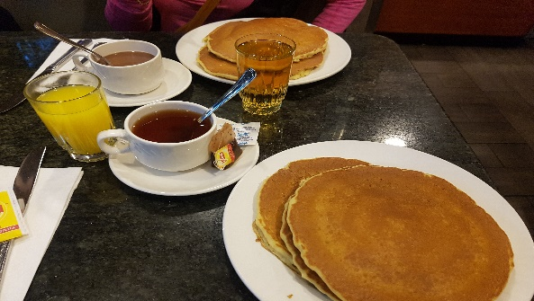
First of all, we return in the hotel to take our breakfast. Let me just be clear about something, this meal is more than a breakfast because with this in your belly, you should forget midday. Nobody could finish this pancakes. We went up 10 minutes in our room and we left immediately to go to the mall.

We spend like 2 hours and more in this mall, it was so long. It’s located in the Time Warner Center and allows to connect the two towers. The name is Columbus Circle and in front of it we have a beautiful view on central park.

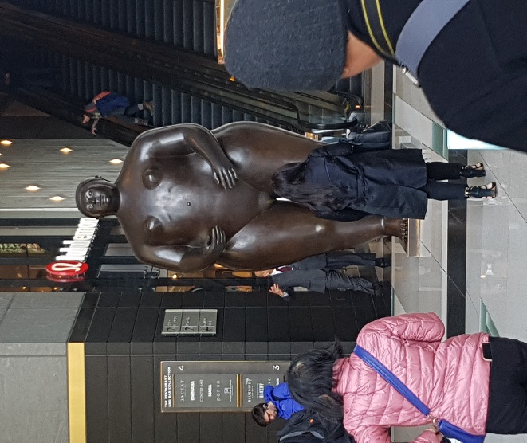
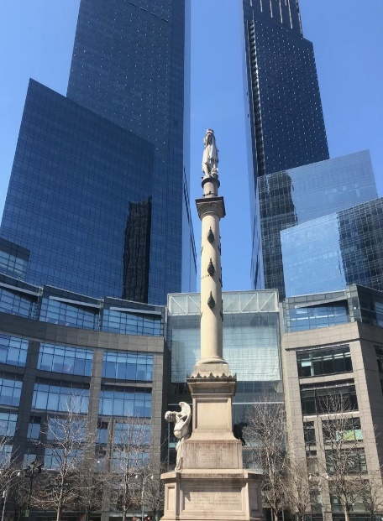
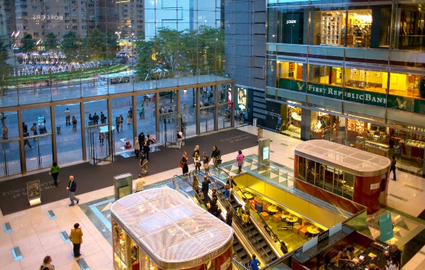
Google and personale photos
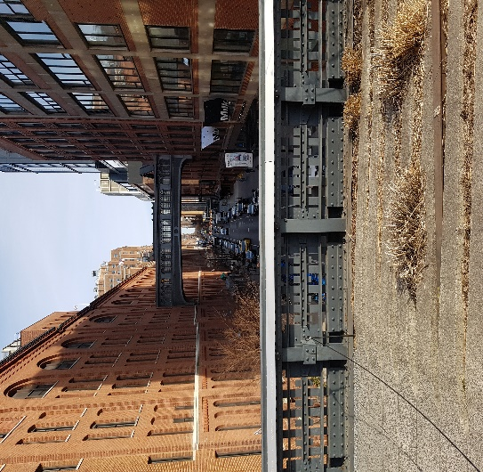
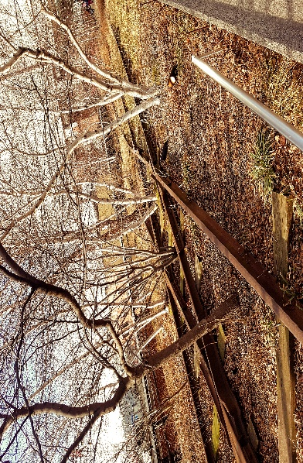
After that, it’s was maybe 2pm we return at the hotel just to drop off all our purchase and then we took the way to the High Line. The High Line is a suspended urban linear park in the Manhattan borough of New York, on a disused portion of the former West Side Line. Despite the surface decay, the bases of the line are well: the bearing structure in riveted steel is exposed, repaired and repainted, the tracks and old concrete screed are deposited. To allow access to the public, many stairs, walkways and lifts have been developed at regular intervals.

We had a charge day and we lunch at 16 pm at Mc Donald’s. At the end, we returned at the Columbus mall to join the other who were eating because they didn’t have time to lunch and we take the opportunity to call our family because the Wi-Fi was good.

Maëlle et Séphora

